Bootstrap colors
Text colors
<p class="text-primary">Primary text</p>
<p class="text-secondary">Secondary text</p>
<p class="text-success">Success text</p>

Background colors
<div class="bg-info text-dark p-3">Info background</div>
<div class="bg-light text-dark p-3">Light background</div>
<div class="bg-dark text-white p-3">Dark background</div>

Color Opacity Variants
<div class="bg-primary bg-opacity-50 text-white p-3">
Semi-transparent primary background
</div>

What is a Container?
A container in Bootstrap is a wrapper element that provides a fixed width or fluid width layout for your content.
Types of Containers
.container
- Provides a responsive fixed width at each breakpoint.
- It automatically adjusts its width depending on screen size.
<div class="container">
<h1>Hello, Bootstrap!</h1>
<p>This container has fixed widths at different breakpoints.</p>
</div>

.container-fluid
- Always takes 100% of the viewport width, on all screen sizes.
<div class="container-fluid bg-light">
<h1>Fluid Container</h1>
<p>This container is always full width.</p>
</div>

.container-{breakpoint}
- Becomes fluid until a specific breakpoint, then fixed width beyond it.
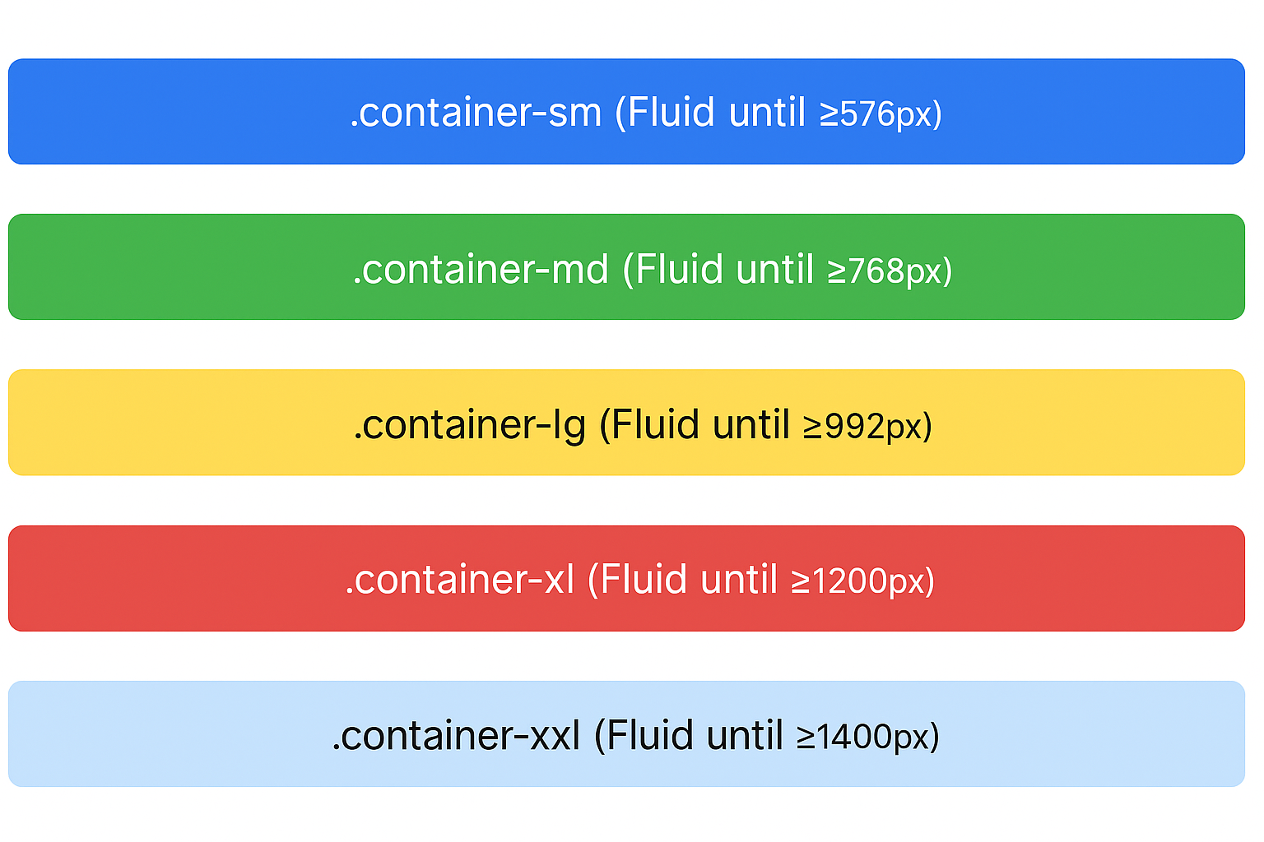
<div class="container-sm">Fluid until small (≥576px) then fixed</div>
<div class="container-md">Fluid until medium (≥768px) then fixed</div>
<div class="container-lg">Fluid until large (≥992px) then fixed</div>
<div class="container-xl">Fluid until extra large (≥1200px) then fixed</div>
<div class="container-xxl">Fluid until xxl (≥1400px) then fixed</div>

What “gutter” means in Bootstrap
In Bootstrap, a gutter is just the space between columns in a row.
Think of it like the “gap” that keeps columns from touching each other.
<div class="container px-4 text-center">
<div class="row gx-5">
<div class="col">
<div class="p-3">Custom column padding</div>
</div>
<div class="col">
<div class="p-3">Custom column padding</div>
</div>
</div>
</div>

Images
Responsive images
Images in Bootstrap are made responsive with .img-fluid.
This applies max-width: 100%; and height: auto; to the image so that it scales with the parent width.
<img src="wall1.jpg" class="img-fluid" alt="...">

Select
Custom <select> menus need only a custom class, .form-select to trigger the custom styles.
Custom styles are limited to the <select>’s initial appearance and cannot modify the <option>s due to browser limitations.
<select class="form-select" >
<option selected>Open this select menu</option>
<option value="1">One</option>
<option value="2">Two</option>
<option value="3">Three</option>
</select>
Badges
Documentation and examples for badges, our small count and labeling component.
Badges scale to match the size of the immediate parent element by using relative font sizing and em units. As of v5, badges no longer have focus or hover styles for links.
<h1>Example heading <span class="badge text-bg-secondary">New</span></h1>
<h2>Example heading <span class="badge text-bg-secondary">New</span></h2>

Buttons
Badges can be used as part of links or buttons to provide a counter.
<button type="button" class="btn btn-primary">
Notifications <span class="badge text-bg-secondary">5</span>
</button>

Positioned
Use utilities to modify a .badge and position it in the corner of a link or button.
<button type="button" class="btn btn-primary position-relative">
Inbox
<span class="position-absolute top-0 start-100 translate-middle badge rounded-pill bg-danger">
99+
<span class="visually-hidden">unread messages</span>
</span>
</button>

